Summer care tips for pets
The temperatures are rising and it is important to take precautions to keep pets safe during these hot summer months. Please remember these tips to prevent heat stress, heat stroke, and other ailments.
-Never leave your pet in the car. Even with the windows down, it can become too hot very fast and your pet can suffer and die. To prevent tragedy, simply choose to leave your pet at home in the comfortable air conditioning.
-Your pet needs clean, cold water at all times.
-Make sure your pet has access to shade when outside. Air should be able to circulate, so shade under a tree is better than an enclosed space such as a shed or dog house.
-Walk your dog during the cooler hours of the day such as early morning or later in the evening. Asphalt can be very hot on a dog’s pads. Walking in the grass can be a better choice.
-Talk to your veterinarian about proper flea, tick and heartworm preventatives.
-Cars can leak anti-freeze in the summer too. Anti-freeze has a sweet taste and can be fatal to your pet even if only small amounts are ingested. Keep pets away from areas where antifreeze is used and thoroughly wipe up any spills immediately.
-Lawn fertilizers and pesticides can be harmful to pets. Avoid recently treated areas and consider pet safe alternatives for your own yard.
-Research healthy recipes for making cool treats for your dog, such as peanut butter popsicles.
- Contact your veterinarian if you have concerns about your pet’s health.
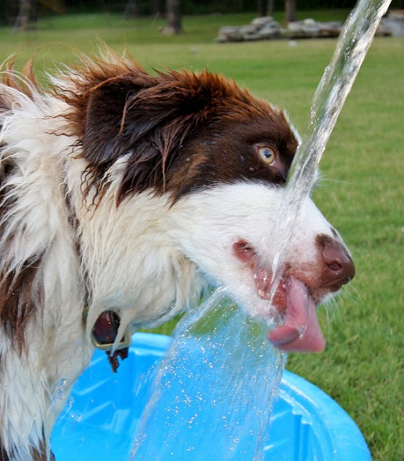
Play it safe and make responsible decisions.
All your friends at Capital Humane Society thank you for
taking good care of your pets all year long.

